Model 4804 In-Cab Sampler
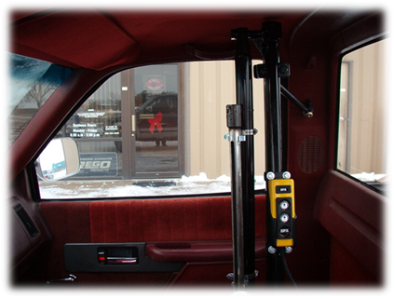

In-Cab Soil Sampler
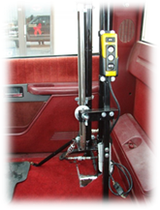
$2,495.00

- Mounts inside cab of most vehicles
- Manual collection of samples
- 1” diameter sample with a depth of 0-24”
- Replaceable cutting tip for all conditions
- Sample all soil types including frozen soil
- Quick attach probe for core removal
- Stainless steel sampling parts
- Push button controls with 10-foot cord
- Fast cycle time of 12-16 seconds
- 12V electric over hydraulic power unit
- 1.75” x 30” cylinder produces 6,000 lbs. of downforce

