Model 2450
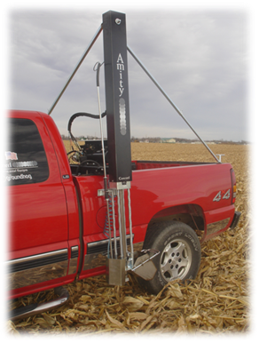

Pick-up Mounted Soil Sampler
Starting at $3,895

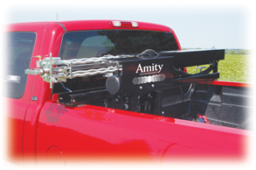
- Sample depth of 0-24 inches
- Automated collection up to 25 samples
- Cycle time: 12-18 seconds
- 12v electric over hydraulic power unit
- Easily adjusts to lay down position
- Push button controls with 10 foot cord
- Stainless steel sampling parts
- Adjustable height for different pick-up models
- Optional air-blast tip cleaner
- Approximate weight: 250 lbs

