Model 2403, 3603, 4803
3- Point Tractor Soil Sampler
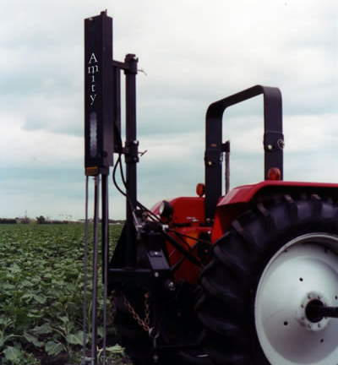
Model 2403 $2,995.00
Model 3603 $3,295.00
Model 4803 $4,695.00

- Sample depth of 24”, 36”, or 48” (1” diameter)
- Replaceable cutting tip for all conditions
- Fast 0-24, 36, 48” sample in 12-30 seconds
- Automated collection system
- Sample all soil types including frozen soil
- Utilizes tractor hydraulics
- Mounts to any category 1, 2, or 3 point hitch

