# Model 2024 Auger Sampler

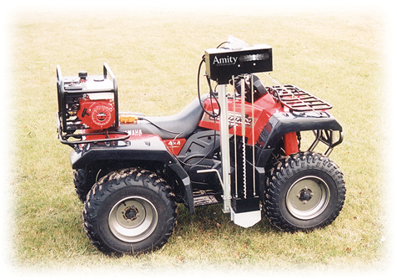

## ATV Mounted Auger Sampler

$4,995.00

* Fast 0-24” sample in 16 seconds or less
* Remove collection bucket without getting off ATV
* Push button controls with 6 foot cord
* Low-profile and can mount to most ATV models
* 6.5 HP Honda hydraulic power pack
* Sample depth of 0-24” with 3/4” diameter auger
* Optional 0-12” attachment with 1” diameter auger
* Specially designed carbide tipped auger
* Sample all types of soil including frozen ground
* Auger rotates up to 1,250 RPM
* Automatic collection up to 15 samples/bucket