Model 4804 Research Sampler 3-Point Tractor Mount
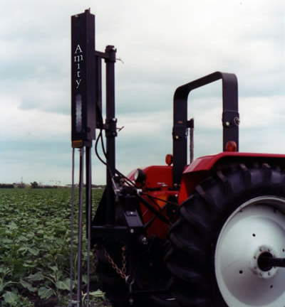

4808 3-Point Tractor Mount

Soil Sampler
$3,695.00

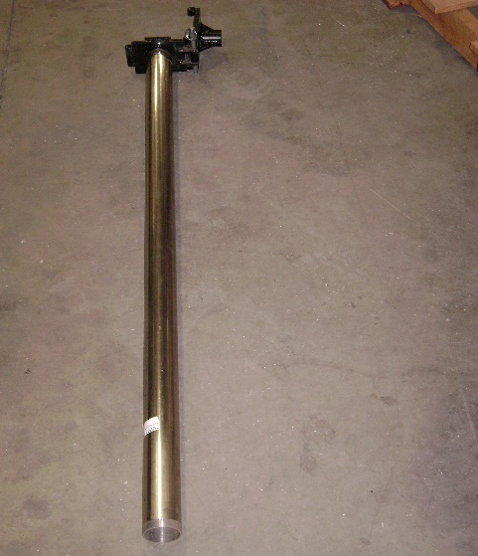
- Sample depth of 0-48” (1 ¼ “, 1 ½ “, & 2” diameter)
- Easy to use swing-away probes
- Acetate liners for soil collection
- Optional 3-stage attachment (2 ¼ “, 4 ½ “ diameter)
- Stainless steel probes
- Utilizes tractor hydraulics
- Sample all soil types including frozen soil

