Davis Weather Station installation
Davis Vantage Pro2 GroWeather wireless ISS, with Vantage Connect. Updated: 6/5/17
This setup is intended to be completed in several stages. The initial assembly can take approximately 45 minutes. Followed by the final field install taking approximately 30 minutes to complete.

- Each station will have 3 boxes:
- Tripod mounting equipment
- Vantage Pro2 GroWeather Wireless ISS
- Vantage Connect

- Unbox, starting with the tripod mount first.
Assembly of the tripod as the first piece will allow you to mount the equipment as it would be in the field location. First assemble the unit in a suitable location such as a workspace or shop location. The equipment can be assembled and easily moved to a final installation site later.
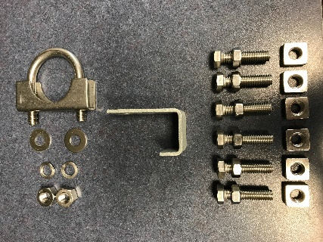
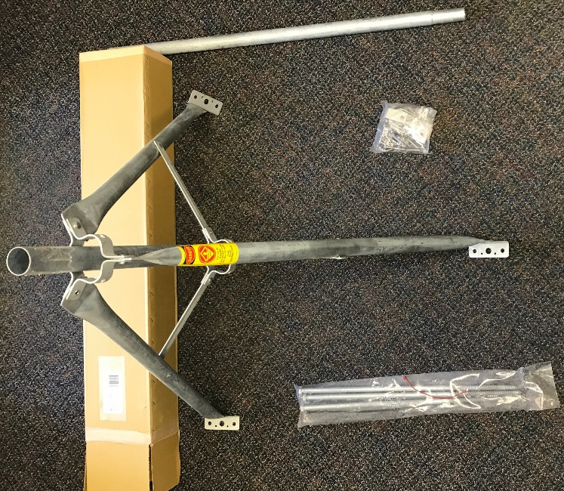

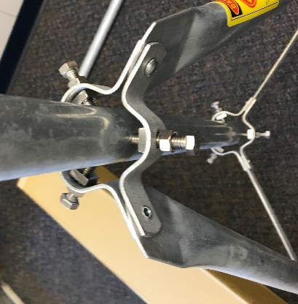

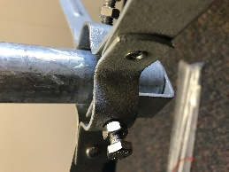
Expand the tripod base, ensuring the feet are flat to the ground surface. Insert the pole section, without the tapered end, vertically in the center of the base. Next prepare nuts and bolts to secure the mounting pole as seen in the above picture. Securely hand tighten at this point. In-field final assembly will require wrench tightening. Please note the “J” channel is intended to be used in the lower bolt area to keep the center pipe from slipping downward. Also, note the hardware you need in the top picture. Extra hardware is packaged but is not necessary for field installs. Finally, the U-bolt assembly will be used to secure the coupler connection when the top extension pipe (with tapered end) is insert into the center pipe.
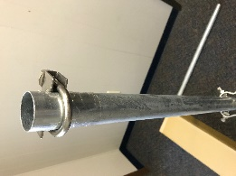

Save the top pipe section with tapered end to be utilized when the Vantage Pro2 GroWeather wireless ISS is assembled.

- Unbox Vantage Connect.
Assemble the U-bolts, loosely onto the top and bottom mounting positions of the Vantage Connect. Then slip over the center pipe of the tripod mount. Securely tighten the U-bolts to the center pipe at a position point half way between the top of the tripod legs and the top of the pipe. Also note that the hinge side of the Vantage Connect should be on the left side, as you look at the unit mounted. Likewise, the enclosure snap locks will be on the right-hand side.
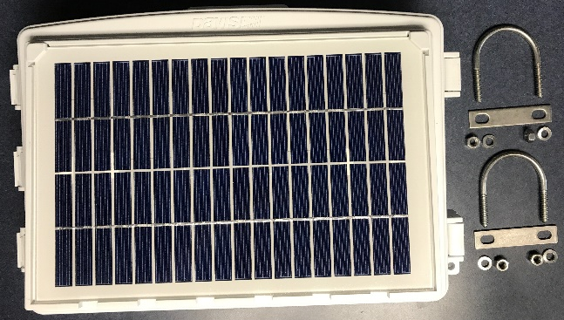
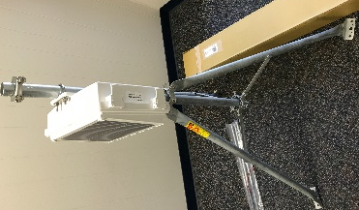

- Unbox the Vantage Pro2 GroWeather Wireless ISS.
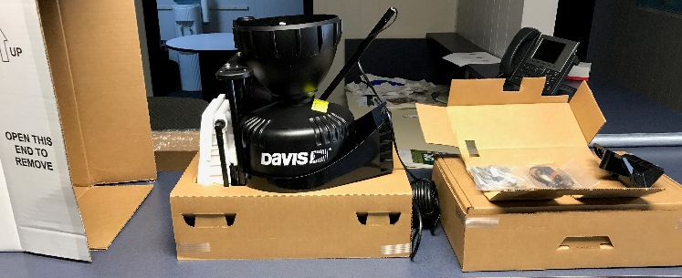

  - Assemble anemometer cups to the wind vane assembly. A small Allen wrench is provided, in the hardware pack, for tightening the set screw on the cups to the shaft. Securely tighten.
  - Add the base black plastic mount to the bottom end of the wind vane mounting shaft. Please note that the wire cable will slip through an intended notch in the circular holder. Also note that the flat side of the plastic should face vertically not horizontally. This insures the wind vane has the proper horizontal resting position. Secure with the tiny bolt and nut included in the hardware pack. Remember to utilize the small star shaped lock-washer, as well.

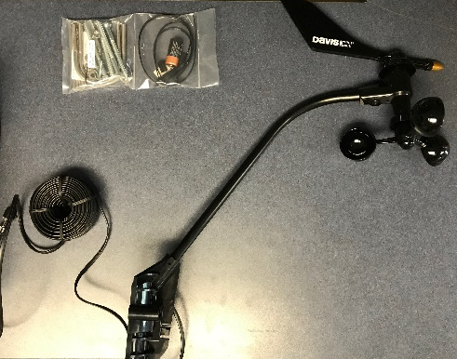

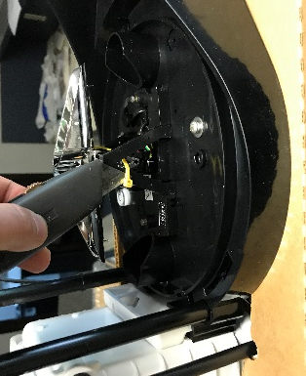
  - Next, twist off the black top of the rain catch bucket and set aside. Clip the yellow zip strap that secures the rain bucket. Without clipping the yellow zip strap, the rain collector will not work properly. Once the plastic strap has been cut, place the black rain collector cover back on top and twist to lock.

  - Insert the rain catch filter inside the top center portion of the rain collection bucket. Again, twist to lock in place.
  - Assemble the U-bolts to attach both the anemometer and rain catch housing to the center pipe.
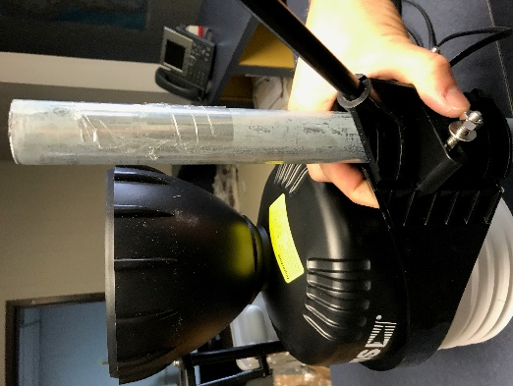

  - Once in proper place, securely tighten the U-bolts with a wrench. Ensure to position the mounting point so that the top of the pipe sticks above rain catch bucket by approximately 5”. Finally, use a plastic zip strap to secure the extra anemometer cable to the pipe.

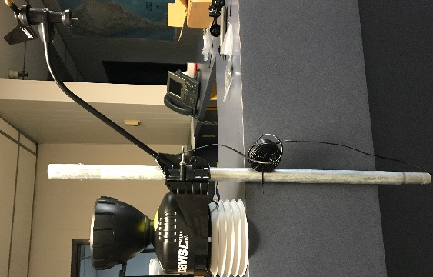

  - Remove the solar panel cover by removing the shipping tape and sliding the cover upwards. Once open, please be careful not to damage the connected wire from the solar panel to the circuit board. The cover can just be placed to the side without removing the wire connection. Remove the piece of weather strip at the bottom corner of the enclosure and feed the anemometer wire through to the inside of the enclosure. Plug the connection into the open port labeled “Wind”. Replace the weather strip to cover the enclose cable route holes.

Important: Ensure that an account has been setup first. Having a proper account setup before power is applied to the unit will ensure a faster connection to the data. If done in reverse the data will be available, However after a 24-hour period of data acquisition.

  - Insert the provided Duracell battery and replace the solar panel cover.

  - Don’t forget to insert the bird spikes around the outer ring of the rain collection bucket!

  - At this point. You can prepare the setup for the field location installation. Place the fully assembled top half of the unit in the vehicle for transport. Also, loosen the tripod center bolts and collapse the tripod. Again, place the mount in the vehicle for transport.

- Field assembly:
  - Place tripod in proper field location. Careful consideration should be taken for proper placement. A desired location is clear of trees, buildings or other structures that would cause false readings in collected weather data. Be sure to keep the location safely away from machine activity involved with the field. Ideally this location would be in a grassy location that is well representative of the field conditions.
  - Secure the tripod base to the ground by driving the lag stakes into the ground through the hole in each of the base mounting plate. If further security is desired, it is advisable to use ground anchors and nylon ratchet straps to provide guy wire type installation (not provided).
  - Once the tripod is level and firmly secured to the ground, install the top section of the weather station and use the u-bolt clamp to provide a friction clamped fit of the pipe sections.

Important: Ensure that solar panels are facing south on both the upper and lower unit. Also, the wind direction vane should be pointing due North. If these directions are not easily available, a navigation feature on a smartphone can help orientate the equipment.

  - Open the Vantage Connect enclosure cover and remove the packaging. This unit is shipped without the battery fully connected. Connect the (red) positive battery lead cable. Once connected the unit is powered and ready to transmit data. Please take a photo of the stations DID, Key and MEI numbers to send along to FarmQA support. This information needs to be pared with the proper account when registering stations.

